AMI SONEJI

SQL Assignment 26/4/2021

# Write a SQL statement to display all the information of all salesmen.

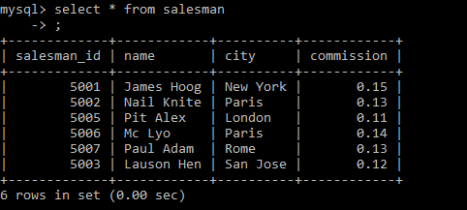

# Write a SQL statement to display specific columns like name and commission for all the salesmen.

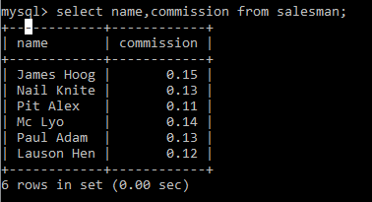

# Write a query to display the records in ascending order of commission.

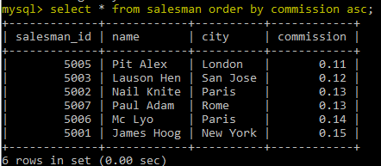

# **4.** Write a SQL statement to display names and city of salesman, who belongs to the city of Paris.

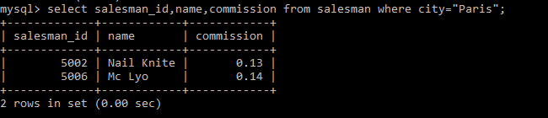

# **5.** Write a SQL statement to display all the information for those customers with a grade of 200.

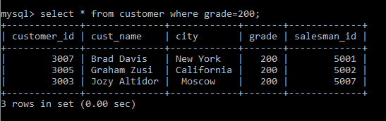

6. Write a SQL query to find all the products with a price between Rs.200 and Rs.600.

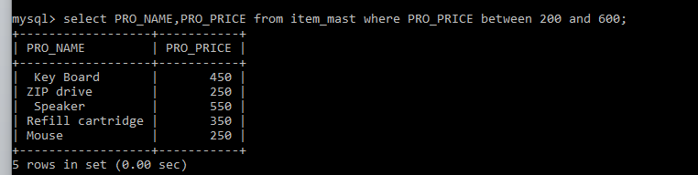

## **7.** Write a SQL query to calculate the average price of all products.

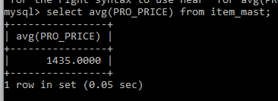

# **8.** Write a SQL query to display the name and price of all the items with a price is equal or more than Rs.250

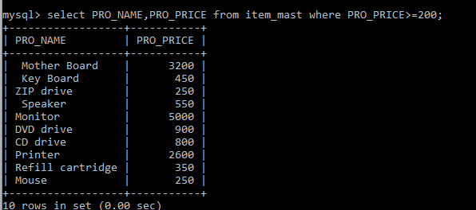

# **9.** Write a SQL query to find the name and price of the cheapest item(s)

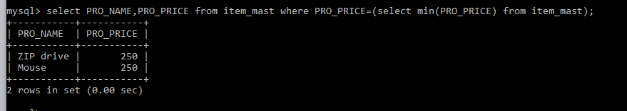

# **10.** Write a query in SQL to find the last name of all employees, without duplicates.

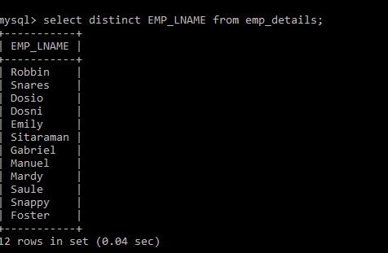

# **11.** Write a query in SQL to display all the data of employees that work in the department 57.

# 